Magento Flow

1. Maintained a Setup

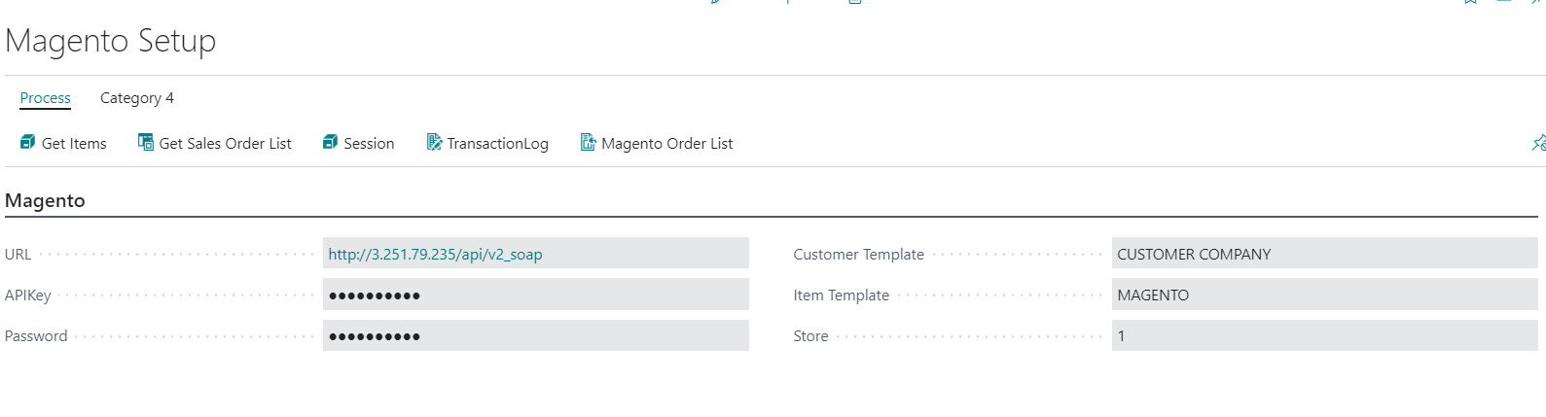

Actions:

Get Items: will fetch Items and will store in Item Master as per Template which Is mandatory

Get Sales Order List: Will fetch all orders and will store in Magento Order List

Session: Every Login will be stored

Transaction Log: Log of Actions Performed

Magento Order List: Opens List of all Magento Orders

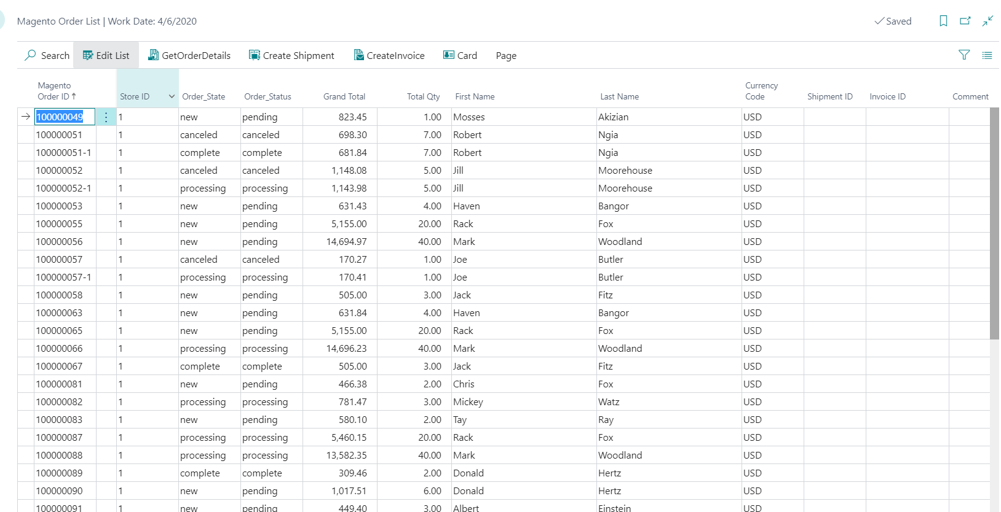

Action:

GetOrderDetails: Will fetch single Order Details and will store details and then with Card Option, Order Data will be available.

Create Shipment: To create a Shipment Request of Order

Create Invoice:To Create Invoice Request